Email 1 – Missed Lecture
Date: October 1, 2026
To: Dr. Nandini Pradeep <nandini.pradeep@klh.edu.in>
Cc: CSE Department Office <cse.office@klh.edu.in>
Bcc: [optional]
From: Shreyesh Reddy <shreyeshreddygudi@klh.edu.in>
Subject: Missed Class on [Date] – Request for Notes/Slides (CSE)
Dear Dr. Nandini Pradeep,
I hope you're having a good week. I'm writing because I wasn't able to attend your lecture on [Date]. I was unwell that day, and I'm sorry to have missed the class, especially since I always find your sessions really helpful.
I'm feeling much better now and have started catching up. I've gone through the textbook chapters related to that topic, but I'd love to see how you explained it in class. Would it be possible to share the slides or lecture notes from that session?
I'd also be grateful if you could let me know whether any announcements, assignment changes, or schedule updates were made that day, so I don't fall behind on anything important. If there's something specific I should review before the next class, please feel free to point me toward it.
Thank you so much for your time and understanding. I really appreciate it.
Warm regards,
Shreyesh Reddy
2620030608
CSE
shreyeshreddygudi@klh.edu.in
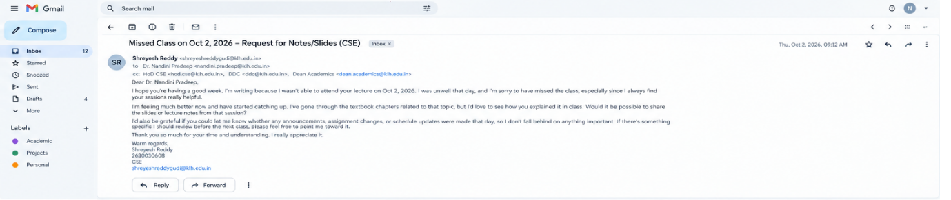

Email 2 – Tech-Fest Update
Date: October 1, 2026
To: Dr. Nandini Pradeep <nandini.pradeep@klh.edu.in>
Cc: Viwentiaa Organizing Committee <viwentiaa2026@klh.edu.in>
Bcc: [optional]
From: Shreyesh Reddy <shreyeshreddygudi@klh.edu.in>
Subject: Viwentiaa 2026 – Progress Update from the Organizing Committee
Dear Dr. Nandini Pradeep,
I hope you're doing well. As a member of the organizing committee for Viwentiaa 2026, KLH Bachupally's annual tech-fest, I wanted to share an update on where we stand. The team has been working hard, and I'm happy to report steady progress.
What we've completed so far:
- The venue is booked, and we've finalized the basic layout plan.
- We've begun reaching out to sponsors, and two of them have already shown interest, which is encouraging.
- The event website and registration form are now live.
- We've drafted the list of core technical events along with a tentative schedule.
What's still ahead:
- Confirming the judges and guest speakers.
- Finalizing the budget and procuring materials.
- Organizing student volunteers for the day-of logistics.
- Preparing promotional material and launching the social media campaign.
We're confident we can wrap up the remaining work by [proposed date]. That said, we'd really value your input. If there's any area you'd like us to focus on, or if you'd like a more detailed report, I'd be glad to put one together or walk you through it in person.
Thank you for your continued guidance and support. It means a lot to the whole team.
Best regards,
Shreyesh Reddy
Organizing Committee – Viwentiaa 2026
2620030608
shreyeshreddygudi@klh.edu.in

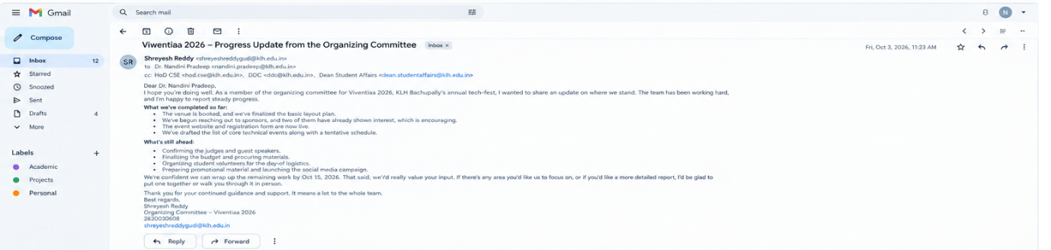
Email 3 – Project Proposal Meeting
Date: October 1, 2026
To: Dr. Nandini Pradeep <nandini.pradeep@klh.edu.in>
Cc: Project Guide <project.guide@klh.edu.in>
Bcc: [optional]
From: Shreyesh Reddy <shreyeshreddygudi@klh.edu.in>
Subject: Could We Meet to Discuss My Project Proposal? – CSE
Dear Dr. Nandini Pradeep,
I hope this message finds you well. I've been working on my project proposal for CSE, and I'd really like to get your feedback before the submission deadline so I can make sure I'm heading in the right direction.
Would you have 15–20 minutes to meet with me? I've listed a few time slots below, but I'm happy to work around your schedule:
- Monday, [Date], between 10:00 a.m. and 12:00 p.m.
- Tuesday, [Date], between 2:00 p.m. and 4:00 p.m.
- Wednesday, [Date], between 11:00 a.m. and 1:00 p.m.
I'm comfortable meeting in your office or over a video call, whichever is easier for you. I'll come prepared with a short outline of my idea and a few specific questions so we can make good use of your time.
Thank you for taking the time to read this. I truly appreciate your guidance and look forward to hearing from you.
Kind regards,
Shreyesh Reddy
2620030608
CSE
shreyeshreddygudi@klh.edu.in

